‘Ancient Aborigines & the Land’

Introduction:

Aboriginal people have inhabited the Australian continent for more than 40,000 years. Archaeologists and scientists believe that the Aboriginal people migrated to this continent During the Ice Age, as large parts of the northern hemisphere were frozen and impossible to live in. But how do we as historians know this? The answer is through sources. Archaeologists in 1975 uncovered the remains of a human male at Lake Mungo in western New South Wales. Through DNA testing, and carbon dating, it was concluded that this man was Aboriginal and lived some 35,000 years ago. Not only is this oldest known remains of an Aboriginal person, it is one of the oldest surviving evidences of humans inhabiting land.

Lake Mungo:

Although this man was uncovered in desert, the Lake Mungo area, at the time of this person’s death was a semi-arid region. This part of Australia was once filled with inland lakes, which created vast lush green areas and woodlands that allowed Aboriginal people to live, hunt and survive here until approximately 15,000 BC.

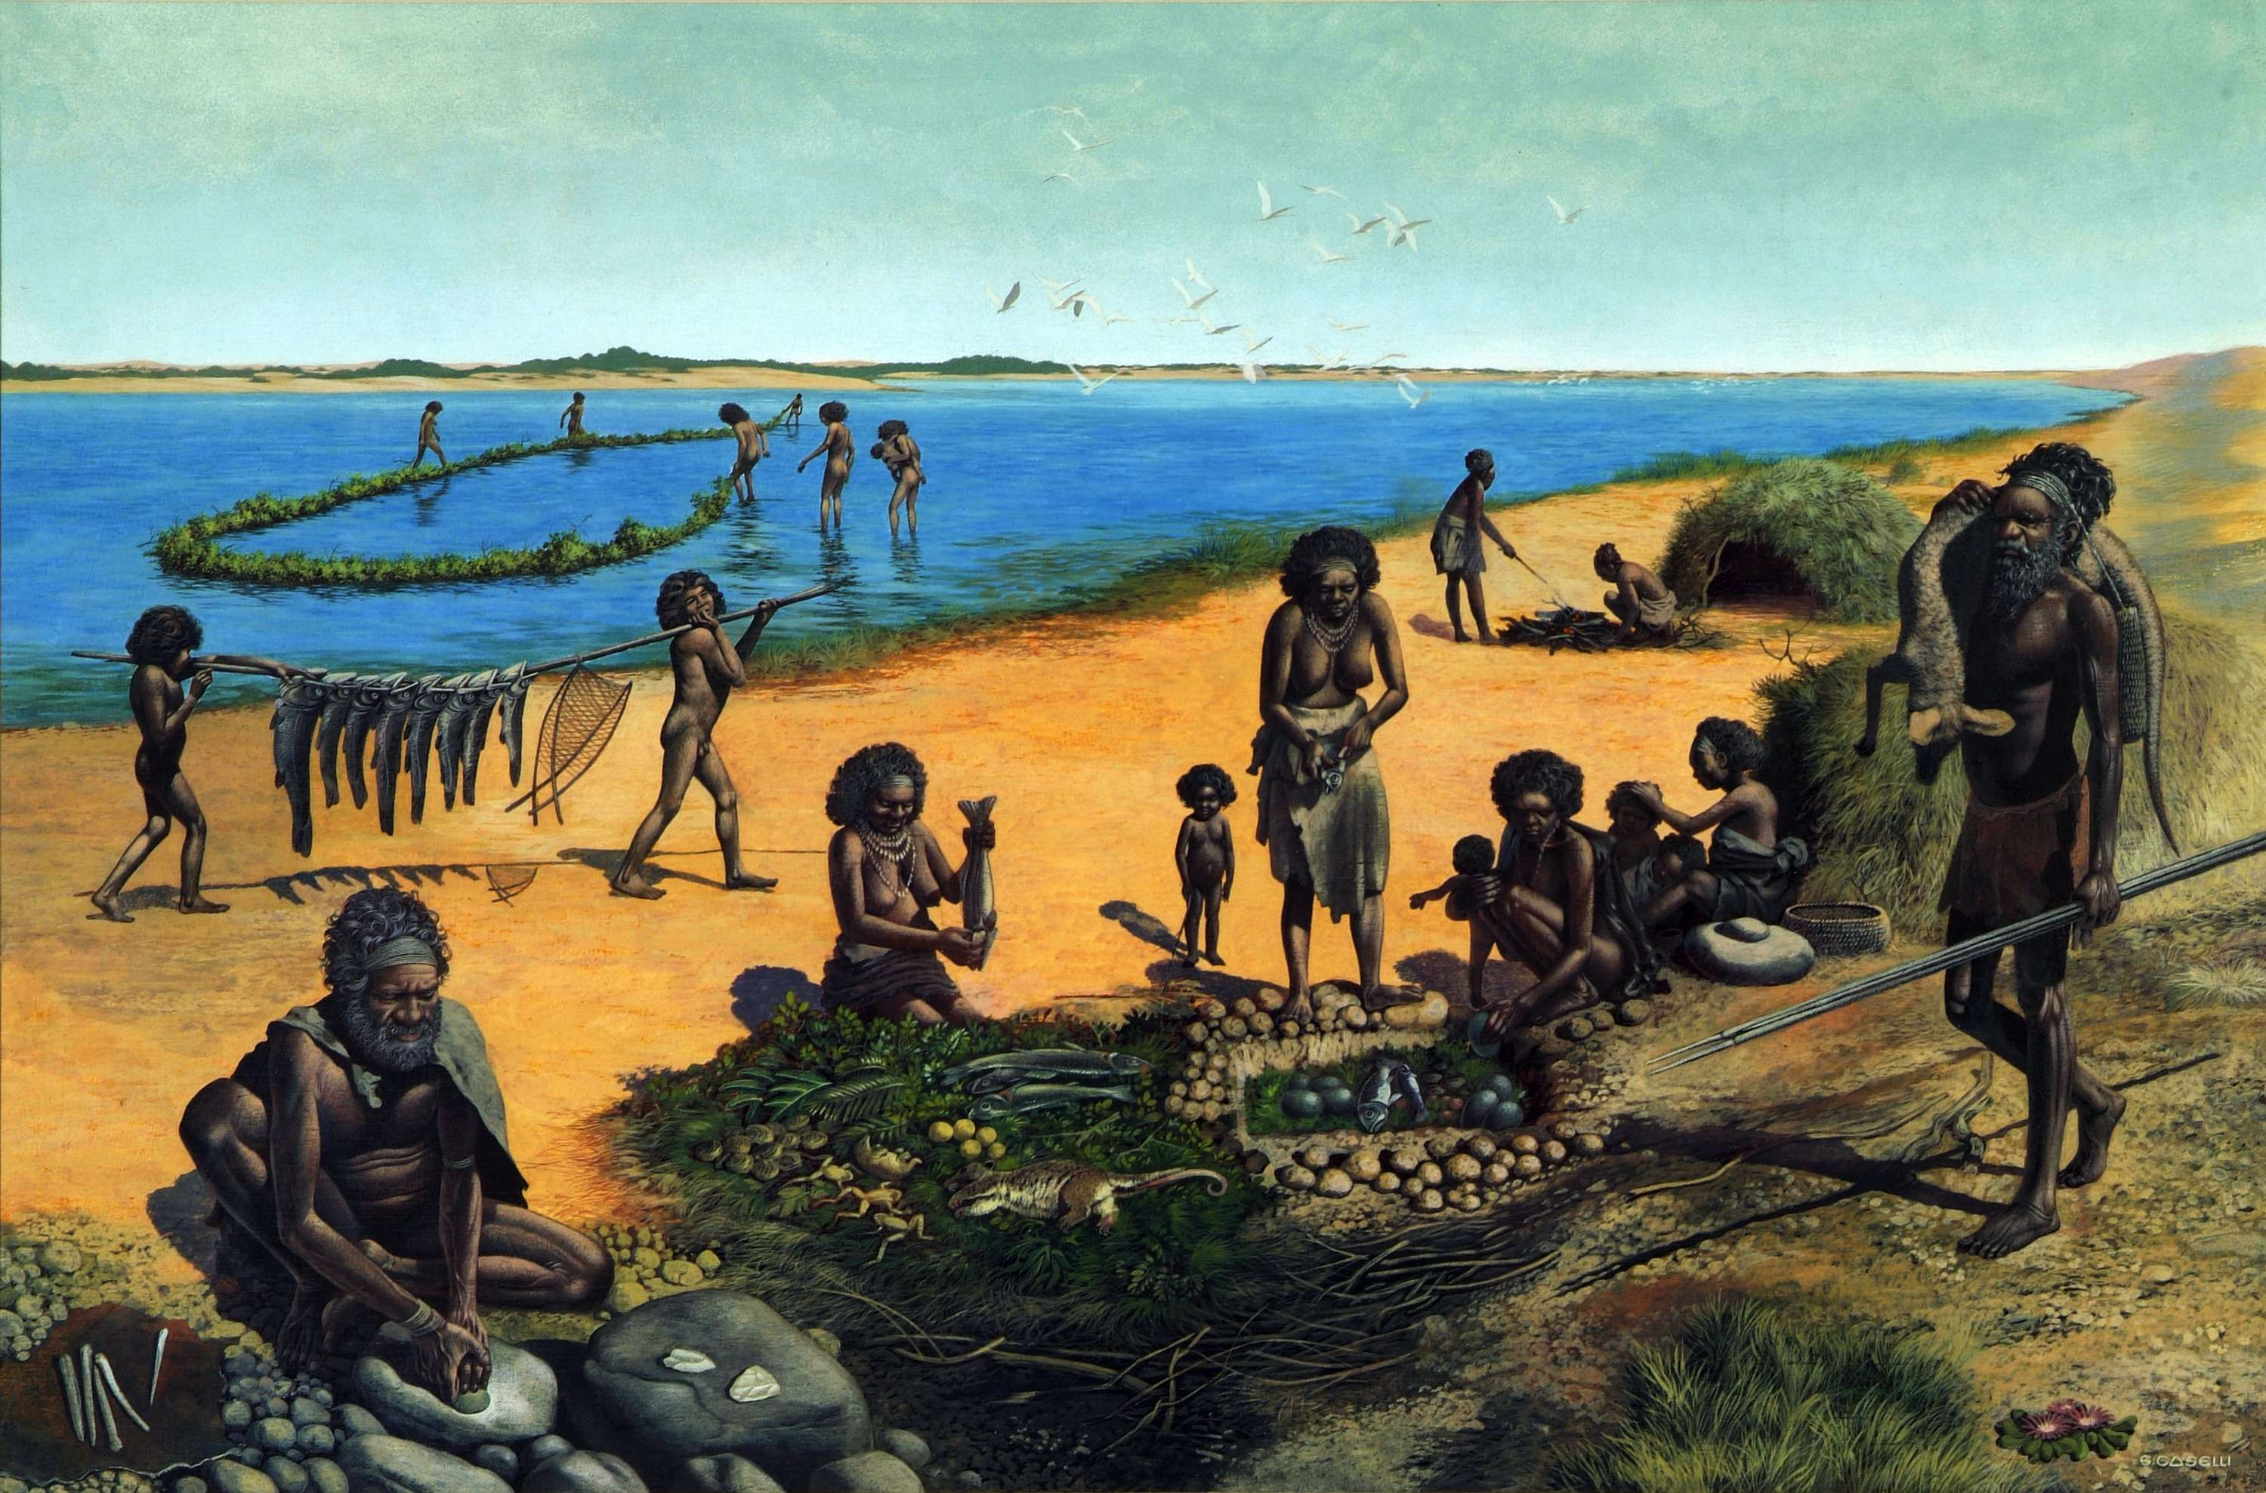
Source 1 Artists impression of Lake Mungo (C. 35,000 BC)

The wet and cool conditions allowed Aboriginal tribes to thrive. The lake provided a varied diet of shellfish, crayfish, Murray Cod and other animals such as Giant Kangaroos and small marsupials.

Using the information provided here, and in the slide show on the class website, answer the following questions:

- Define the term ‘Aborigines’

- Explain the traditional Aboriginal beliefs about the land

- Which explorers visited the continent before the English in 1770?

- Why is the finding of ‘Mungo Man’ at Lake Mungo important for historians?

